Assignment 2
Module: Fundamentals of Data Science
Student Name: Sizone Giri

Program 1:

Description of the Program:

A program that accepts a string and calculates the number of lower case and uppercase letters

Source Code:
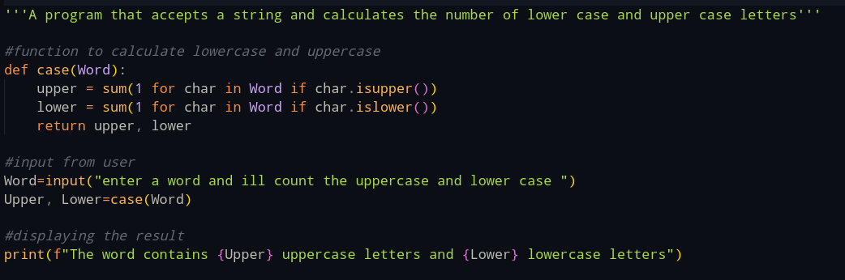
Output Screenshot:
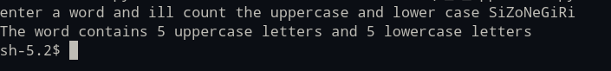

Program 2:

Description of the Program:
A program to check whether the number given by the user is prime or not
Source Code:
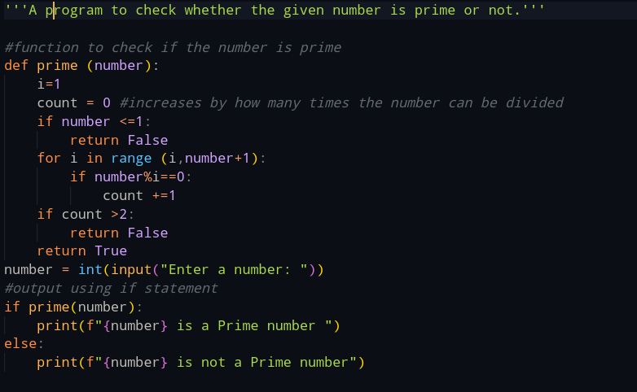

Output Sceenshot(s):

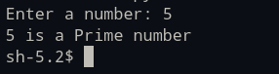

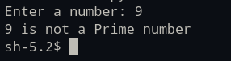

Program 3:

Description of the Program:
A program to check whether the given number is armstrong or not

Source Code:
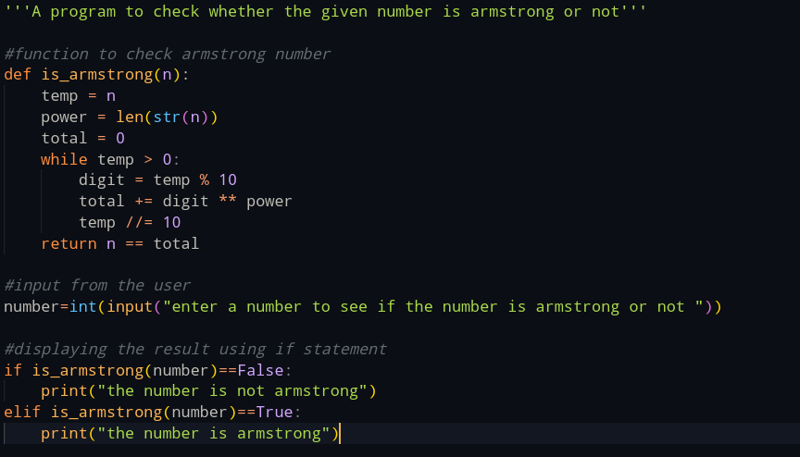

Output Screenshot(s):
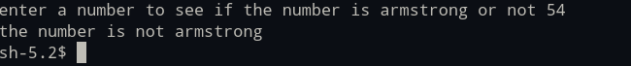

Program 4:

Description of the Program:
A program that accepts a list of names and returns the sorts the names based on alphabetical order.

Source Code:
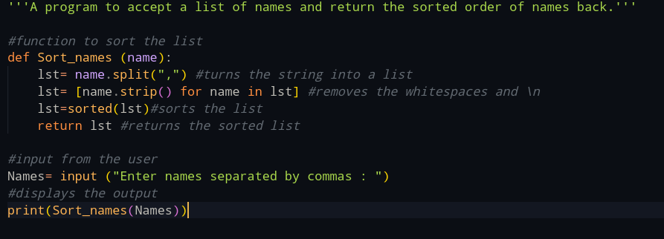

Output Screenshot:

Program 5:

Description of the Program:
A calculator program that does the following:
1.Addition
2.Subtraction
3.Multiplication
4.Division
5.Truncated Division
6.Modulus
7.Exponentiation

Source Code:
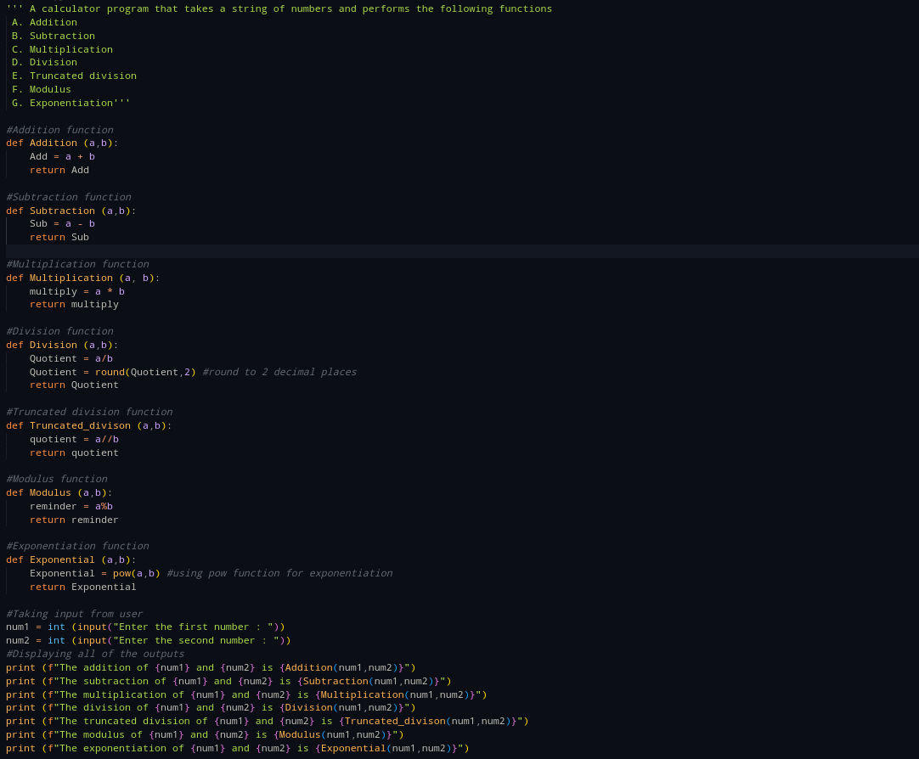

Output Screenshot:
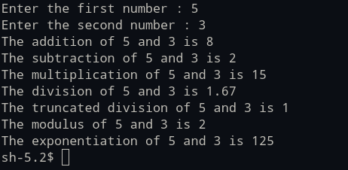

Program 6:

Description of the Program:
A program that prompts the user for a series of integers and stores in a list only the values between 1-100

Source Code:
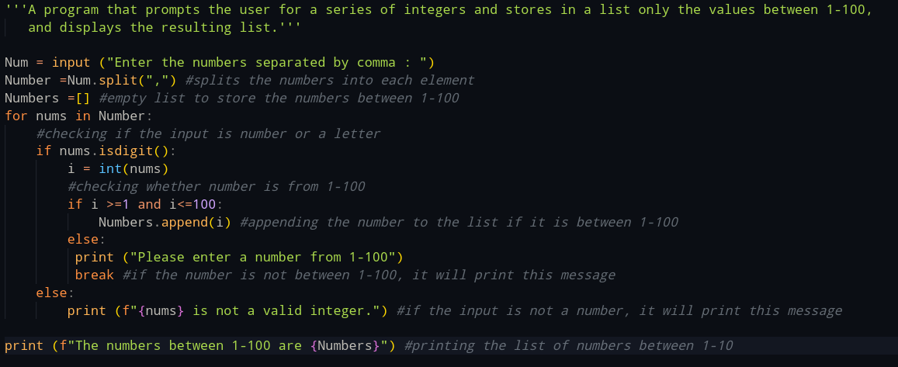

Output Screenshot:
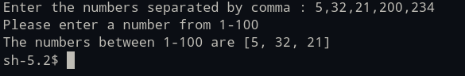

Program 7:

Description of the Program:
A program that prompts the user to enter a list of names and store them in a list.
The program then will display how many times the letter 'a appears within the list.

Source Code:


Output Screenshot:
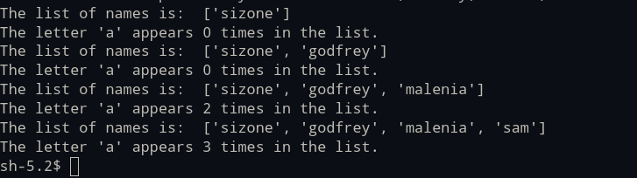

Program 8:

Description of the Program:
A program that prompts the user to enter integer values to populate two lists,
then prints messages to determine the following:
(a) Whether the lists are of the same length.
(b) Whether the elements in each list sum to the same value.
(c) Whether there are any values that occur in both lists

Source Code: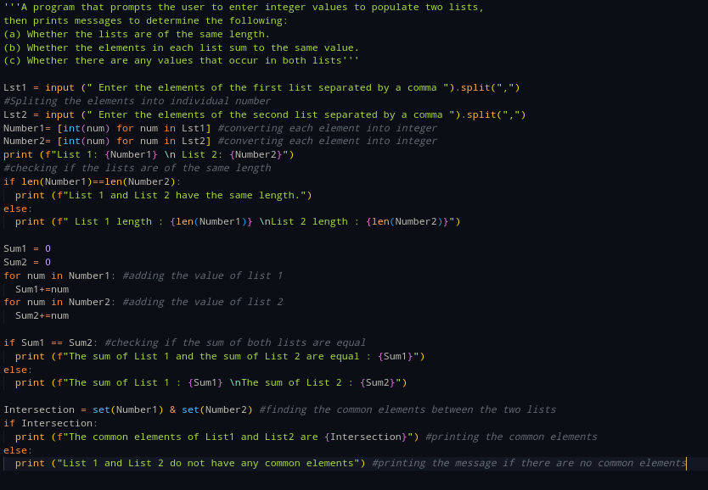

Output Screenshot: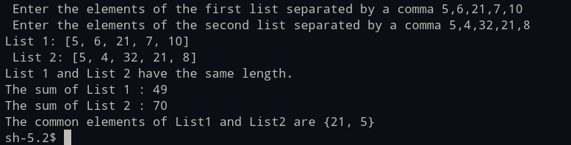

Program 9:

Description of the Program:
A program that has a function called add_daily_temp that is given a (possibly empty) dictionary meant to hold the average daily temperature
for each day of the week, a temperature value, and the day of the week for the recorded temperature.
The function then adds the temperature to the dictionary only if it does not already contain a temperature for that day.
The function then returns the resulting dictionary, whether it is updated or not.

Source Code:
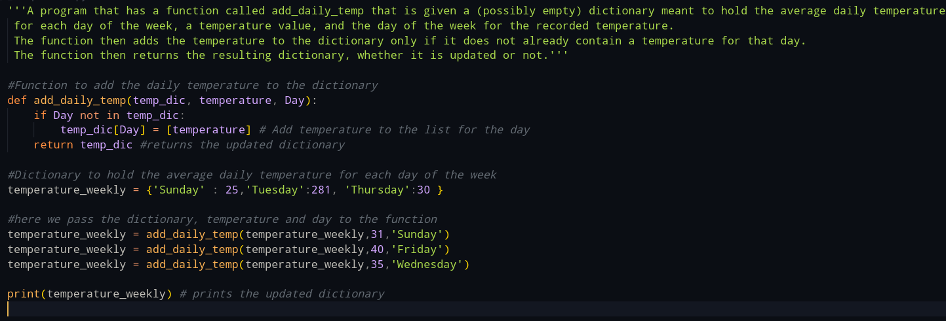

Output Screenshot:

Program 10:

Description of the Program:
A Program with function named get_daily_temps that prompts the user for the average temperature
for each day of the week and returns a dictionary containing the information the user entered.

Source Code: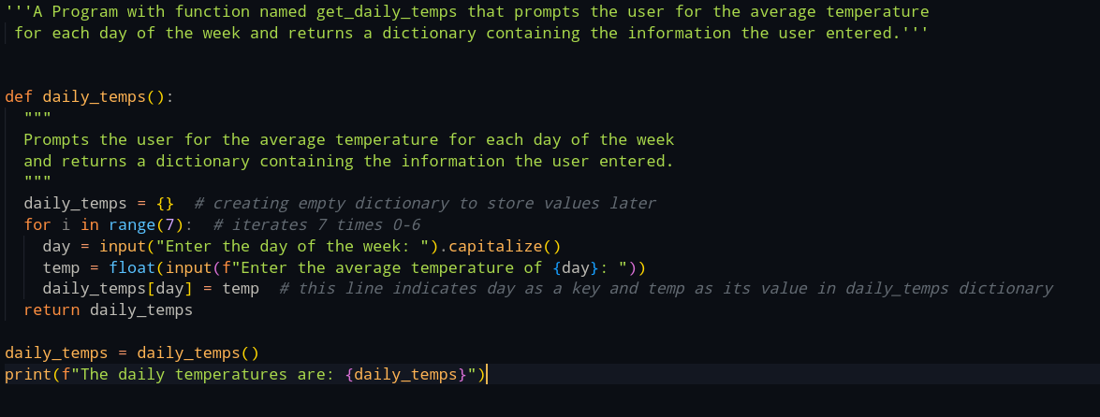

Output Screenshot:
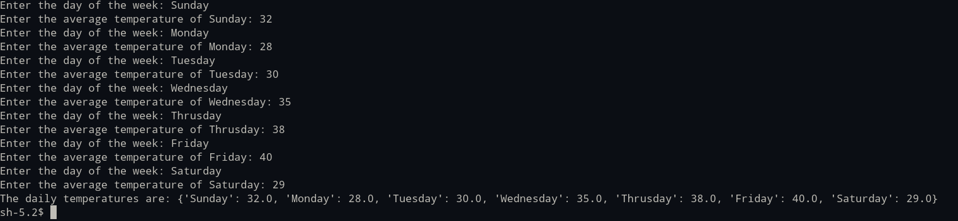

Program 11:

Description of the Program:
A program to create three dictionaries:
dic1 = {1:10, 2:20}
dic2 = {3:30, 4:40}
#dic3 = {5:50, 6:60}
and do the following tasks:
(a) Write code to concatenate these dictionaries to create a new one.
Create a variable called nums to store the resulting dictionary.
(b) Write code to add a new key/value pair to the dictionary nums: (7, 70)
(c) Write code to update the value of the item with key 3 in nums to 80
(d) Write code to remove the third item from dictionary nums.
(e) Write code to sum all the items in the dictionary nums
(f) Write code to multiply all the items in the dictionary nums
(g) Write code to retrieve the maximum and minimum values in nums

Source Code:

dict1 = {1:10, 2:20}
dict2 = {3:30, 4:40}
dict3 = {5:50, 6:60}

# Create an empty dictionary to store the concatenated result
combined_dict = {}

# Add items from dict1, dict2, and dict3 to combined_dict
combined_dict.update(dict1)
combined_dict.update(dict2)
combined_dict.update(dict3)
print(f"The concatenated dictionary: {combined_dict}")

# Add a new key-value pair to combined_dict
combined_dict[7] = 70
print(f"Dictionary after adding new key and value: {combined_dict}")

# Update the value of key 3 in combined_dict
combined_dict[3] = 80
print(f"Dictionary after updating the key 3 value to 80: {combined_dict}")

# Remove the item with key 3 from combined_dict
combined_dict.pop(3)
print(f"Dictionary after removing the third item: {combined_dict}")

# Calculate the sum of all values in combined_dict
total_sum = 0
for value in combined_dict.values():
total_sum += value
print(f"The total sum of all items: {total_sum}")

# Calculate the product of all values in combined_dict
total_product = 1
for value in combined_dict.values():
total_product *= value
print(f"The total product of all items: {total_product}")

# Find the maximum and minimum values in combined_dict
max_value = max(combined_dict.values())
min_value = min(combined_dict.values())
print(f"Maximum Value: {max_value}\nMinimum Value: {min_value}")

Output Screenshot:
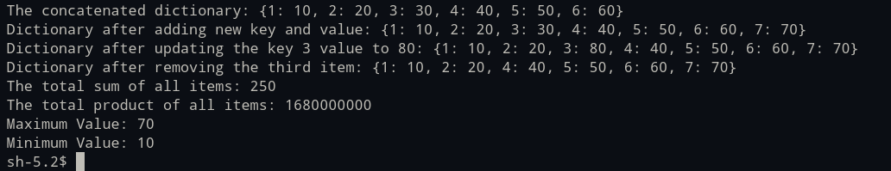

Program 12:

Description of the Program:
A program to create two sets:
set1 = {20, 40, 60}
set2 = {10, 20, 30, 40, 50, 60}
and do the following:
(a) perform a union of these sets. Print the length of the resulting set.
(b) perform an intersection of set1 and set2.
(c) to compute the symmetric difference between set1 and set2
(d) to add the value 40 to set1, did the set change?
(e) to remove value 20 from set2

Source Code:
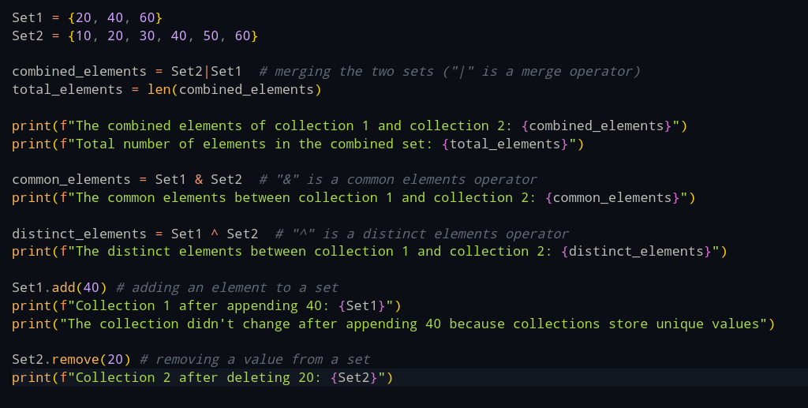

Output Screenshot:
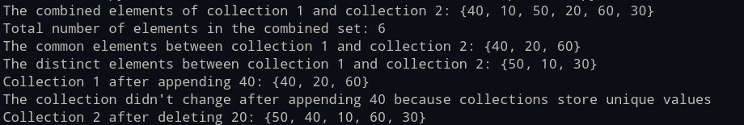

Program 13:

Description of the Program:
A program with a function called word_intersection that prompts the user for two English words, and displays which letters the two words have in common.

Source Code:
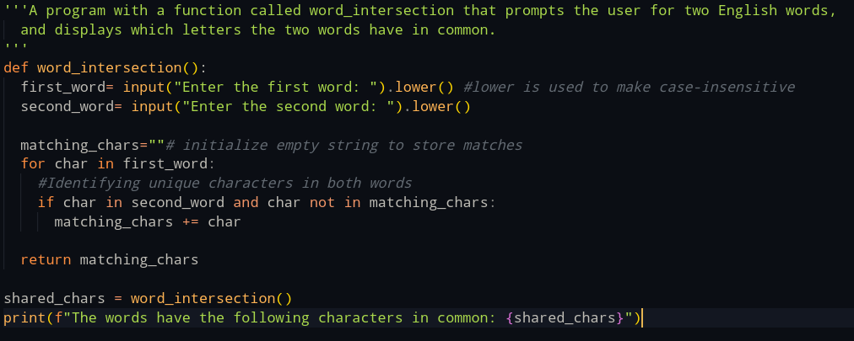

Output Screenshot:
